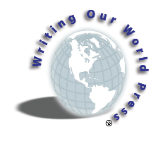

Dear Southern Writers,
Writing our World Publishing, and the Read.Write.Share Writers Weekend, are proud to announce that the 2021 Volume IV Southern Stories Anthology is available for purchase as www.wowpublishing.org ! The 2022 Southern Anthology submissions opens May 1 and closes August 1, 2022. The Southern Stories Anthology consists of short memoirs/personal stories from new, emerging or previously published writers. Although we have made every effort not to add a submissions fee to our Anthology; the continued increase in printing costs have forced us to do so. As of this year, we are requesting a $25 submission fee per Anthology Submission.
Criteria:
- Writers must exhibit an understanding of basic writing skills and the crafting of story.
- Stories may include no more than 2000 words. (Stories may be shortened dependent on layout needs.)
- All submissions this year should be written around the theme of “Surviving Life’s Storms,” stories of inspiration and motivation during the COVID Pandemic.
- All submissions must include a high quality (at least 300 dpi) jpeg or vector image.
- All submissions must be forwarded via email, to: janis@wowpublishing.org
- While all stories will be reviewed. no more than 20 stories will be selected for inclusion in the Anthology. If your story is not selected, your submission fee will be refunded.

If you have questions, please submit them to janis@wowpublishing.org.
*Checks must be received within 10 days of receipt of your submission. Mail to: WOW Publishing Southern Anthology, 2 Rosier Court, Little Rock, AR 72211
Best,

Janis F. Kearney, Cofounder
Read.Write.Share. Writers Weekend

